Group 5
Yue-Tsz Fan, Wei-Yu Chen, Zenghui Sun
Problem Statement
Effective patient allocation can directly impact patient survival, as delays or misallocation may lead to severe deterioration in critically ill patients. These decisions also need to balance efficiency with fairness, avoiding biases related to factors such as insurance status. The challenge is that patient health states evolve dynamically over time, and the progression of critically ill patients is inherently uncertain. This makes it difficult to accurately model how a patient’s condition will change with or without ICU intervention. We aim to build model-based RMAB using MIMIC-IV dataset to provide better patient allocation and ensure fairness.

Related Work and background
Patient allocation is a sequential resource-allocation problem under uncertainty: hospitals have limited ICU beds, patient conditions evolve over time, and allocation decisions must balance efficiency with fairness. We use MIMIC-IV as the primary data source because it provides large-scale longitudinal ICU and emergency department records that are suitable for learning patient states, transition dynamics, and potential bias from non-clinical variables.
Prior work in critical care reinforcement learning has mostly focused on treatment recommendation rather than ICU-bed allocation. The AI Clinician showed that RL can be used for sepsis treatment decision-making in ICU data, while Oberst and Sontag introduced a simplified synthetic sepsis simulator for counterfactual off-policy evaluation. The simulator only models one patient in ICU instead of multiple patients ICU allocation. These studies motivate our project to focus not only on predictive performance, but also on fairness and clinical plausibility in sequential ICU allocation.
Methodology & Algorithm
We model patient allocation as a restless multi-armed bandit (RMAB). Each patient is an arm, and each day the hospital can allocate ICU care to at most K new patients. RMAB is suitable because (1) ICU resources are limited, and (2) patients’ conditions evolve over time regardless of whether they are admitted to the ICU, making the restless setting closer to reality.
To make the problem tractable and easy to evaluate, we discretize patient condition into a shared finite state space and learn two transition dynamics from MIMIC-IV: one for patients outside the ICU and one for patients receiving ICU care. The two dynamics use the same states, but different transition probabilities, so that ICU assignment changes the patient’s dynamics. We assume a fixed ICU stay length of 7 days. Decisions and state transitions occur at the same daily granularity. Each day, some patients will be discharged from ICU because of the fixed ICU stay length, and assume there are K vacancies in ICU now. The policy selects up to K patients for ICU admission on that day. This avoids the mismatch between one-step actions and multi-day ICU occupancy.
The state space consists of discretized vital signs and other clinical observations. For example, one naive way to define the finite state machines is:
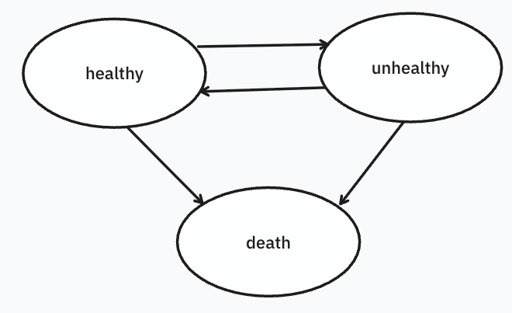
With each circle as a state and each arrow has transition probability, we can model the patient's transition dynamics. Two finite state machines are used to model non-ICU and ICU situations. The state spaces are the same and only the transition probabilities differ. We will look into MIMIC-IV to determine the more reasonable finite state machine.
We will train two versions of the model: one using all variables available in MIMIC-IV, and the other using only health-related variables. Comparing the resulting policies may provide insight into fairness, since non-clinical variables such as insurance may introduce bias. The reward is defined at the population level based on how many patients in each health state each day. For example, if we define r(s) reward for one patient in state s, and k patients are in state s. The daily reward includes k * r(s) summed over all states. In this way, healthier states receive higher reward and critical or terminal states (e.g. death) receive lower reward. Because the arms are finite-state and the action is still binary (ICU or non-ICU), we can study a Whittle-index style policy after defining state rewards and testing indexability.

